Geometry: Unit 11, Lesson 2
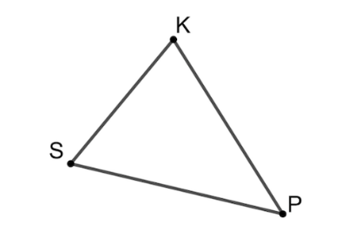
- Triangle $SKP$ is shown. What type of triangle is $SKP$?

Acute triangle

- What types of geometric figures can bisect an angle?

Ray, line, and segment

- An angle bisector is a line, ray, or segment that cuts an angle into what?

Two equal parts

